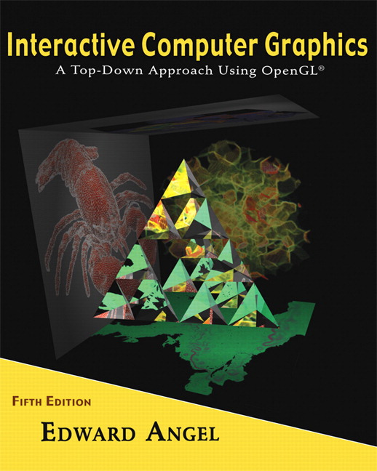

Name: ______________________ Terminal # ____

Programming Assignment 4
(100 points)

The Programming Assignment is to be turned in the first ten minutes of the due date class as:

Hardcopy (with your terminal #!)
Source Code and screenshots that shows that your Visual Studio 2008 “Programming Assignment 4” PROJECT compiles and runs!

Electronic: Submit the Visual Studio2008 “Programming Assignment 4” zipped PROJECT to BB so you can run it in 200 PGH!

“S’COOL BUS Summer 2012” Color & Shading and Texturing Instructions
(The file “S’COOL BUS Summer 2012.pdf” contains the specifications for the BUS.)

1. The glutCreateWindow OpenGL call will take as parameter “YourLastName Final BUS”.
2. Start with the LastNameBUS.c that you have created in Programming Assignment 3 and call the file LastNameFinalBUS.c.

3. Create 2 particle systems spheres, texture map them (happy faces??) and place them one in the driver seat and the other one in the location of the back of the bus centered.

4. Navigating:
Navigate starting at DOOR towards your spheres with the intent to collide with them. When you collide with the spheres you can simulate any desired effects like explosion, etc. Successful collision with the 2 spheres will mark the completion of your summer project.

Get screenshots of the INSIDE of “YourLastName Final BUS” for each view and please comment on what the screenshot is about.

